Understanding Todays News to Predict Tomorrows Stock Market

Gaurav Jariwala¹,Harshit Agarwal¹and Vraj Jadhav¹

- Sarvajanik College of Engineering and Technology, Surat, India
{gjariwala9, 9arshit, vrajjadhav0073}@gmail.com

Abstract.The paper proposes a progressive conclusion on the application of recurrent neural networks in stock price forecasting. We have also used random forest classifier to factor in the sudden fluctuations in stock prices which are derivatives of any abnormal events. Machine learning and deep learning strategies are being used by many quantitative hedge funds to increase their returns. Finance data belongs to time series data. A time series is a series of data points indexed in time. The non-linearity and chaotic nature of the data can be combated using recurrent neural networks which are effective in tracing relationships between historical data and using it to predict new data. Historical data in this context is time series data from the past. It is one of the most important and the most valuable parts for speculating about future prices. Long Short-Term Memory (LSTM) are capable of capturing the most important features from time series data and modelling its dependencies. Building a good and effective prediction system can help investors and traders to get a glimpse of the future direction of the stock and accordingly help them mitigate risk in their respective portfolios. The results obtained by our approach are accurate up to 97 percent for the values predicted using historic data and 67 percent for the trend prediction using news headlines.
Keywords: K-Means Clustering, Naïve Bayes, Random Forest Classifier, Support Vector Machine, Sentimental Analysis.

1 Introduction

  - Motivation

Stock market now a days has become a obsession among the millennial. It is a place where anyone can join without much of an effort and the main reason to join is none other than money. Although it sounds simple to buy at low price and sell at high price for profit in stock market but it is not what it sounds like. First question that should arise in mind is which price can be consider lower and which price can be consider higher as there has to a standard through which one can compare the current price and place them in respective categories. And let’s assume that one comes to know that a given price is significant low price than to other question that should arise is what is the particular reason for stock to be trading at a low price.
In today’s market one can find significant amount of scripts which are management or operator driven what it means is that they drive the price of the stock up and down as per there convinces as the number of shares with them is a lot. And as per the rule of demand and supply one with a huge amount of product can drive the price as per there wish and in stock market if one person is making money than there has to be someone who would be losing money. So, in this game of management and operators innocent retail investors loses a lots and lots of money.

Second thing that drives the stock price are news related to that stock. News is one of the key ingredients which will drive the sentiment of the market and sentiment can have a huge effect on the price of stock. Let’s say news for a particular stock states that its quarter is going to be exponentially good. The effect of these news on stock will be significant in terms of price of stock. one can see an upside in price in coming days without a doubt. And it can also be other way round say the news says the quarter is bad then too the effect of news on stock is going to be significant and would drown the stock price. New on quarter of stock is one of the examples of effect of news on price of stock. There are other news due to which there can be a change in price. From news one can even know if this particular stock is management driven or not, cause if it is so there has to be some news about case or strong action against management. So sentimental analysis is a very important concept which is responsible for the change in stock price.

  - Contribution

Finance produces time series data. A time series is a series of data points indexed in time. Usually, a time series is a sequence taken at successive, equally spaced points in time: a sequence of discrete-time data. Time series data here refers to the indicators which traces the volatility in the prices of a stock on any particular day. These performance indicators are opening stock price (`Open'), closing price (`Close'), intra-day low price (`Low'), intra-day highest price (`High'), and total volume of stocks traded during the day (`Volume').

Recurrent neural networks have been the most effective system to analyze sequential time series data and find relationships between historical data to forecast new data. Historical data in this context is time series data from the past. It is one of the most important and the most valuable parts for speculating about future prices.

Neural networks are interconnected data processing components that are composed of layers of artificial neurons (network nodes) that can process input and forward output to other nodes in the network. The nodes are connected by edges or weights that influence a signal's strength and the network's ultimate output.

Long Short-Term Memory (LSTM) networks are a modified version of recurrent neural networks, which makes it easier to remember past data in memory. LSTM is well-suited to classify, process and predict time series given time lags of unknown duration. It trains the model by using back-propagation.

Sudden massive fluctuations in the price which disrupts the pattern most of the time are derivatives of abnormal events. Accuracy of prediction depends on how well these factors are adjusted. We have used Random forest classifier for the classification of stock’s news headlines. Using these classifications, we generate labels for any particular news and then try adjusting the prices depended on the effect of the news on the stock price.

  - Organisation

The remaining paper is organized as follows: Section 2, summarizes the related work done in this domain; Section 3, describes our approach and implementation; Section 4 describes the results obtained from the different systems; Section 5 summarizes the conclusion and future directions of the concept.

2 Related Work

Győző Gidófalvi [1] hereby presents us with an approach to use a news article for anticipating the price trend rather than predicting a precise value. he has used naïve Bayesian text classifier to make classes (up, down, unchanged) then they compared the news article for that specific stock with the price movement of that stock before and after 20 minutes of news article been published. The predictive power of algorithm was not good but they found a strong link between the news article and the change in stock price in the time interval of 20 minutes before and 20 minutes after the news article was published

Pegah Falinouess [2] have used a different approach to label the news from the article and has compared it with the random news labelling .the algorithm they have used is support vector machine (SVM). When the results were compare the accuracy of her model was 83 percent whereas the accuracy of random news labelling was 51 percent

Yauheniya Shynkevich1 , T.M. McGinnity1,2, Sonya Coleman1 , Ammar Belatreche [3] used a method of dividing the news from news article into five categories these categories were based on news relevant to the specific stock, news related to its sub industry, news relevant to its industry, news relevant to group of industry and news relevant to its sector. Different types of kernels were used to learn from these subsets. from various methods used Math kernel library (MKL) proved to be appropriate one with good results.

Adam Atkins, Mahesan Niranjan, Anrico Gerding [4] they explained that the change in volatility were better predicted than the close price of the asset as per there model. There main aim was to show the relationship between news driven information and implied volatility of the underlying stocks . the implied volatility were derived from the option pricing formula

3 Methods

We are using sentiment analysis methods on news headlines for the stock whose next day’s movement is to be predicted. The news headlines are extracted from the web using web scrapping from moneycontrol.com [reference] and the data is pre-processed and cleaned. After that, each headline is classified as positive, negative and neutral. Scikit-learn library [103] is used for data analysis and Natural Language Toolkit (NLTK) library [104] is utilized for language processing.

The data consist of the news headlines of the stock and labels to predict if the value of the stock will increase or decrease on the next day. The label for the current day is calculated by subtracting the close value of current day from the close value of the previous day, if the resulting value is negative then the label will be ‘1’ and if the resulting value is positive or zero then the label will be ‘0’, as shown in equation (1). ‘1’ means the value of the stock has increased and ‘0’ means the value of the stock has decreased or is the same.

$$L_{c}= \left\{\begin{aligned}\begin{aligned}1 when C_{p}-C_{c}<0 \\ 0 when C_{p}-C_{c}≥0\end{aligned} \\ \end{aligned}\right. ( SEQ "equation" \backslash n \backslash * MERGEFORMAT 1)$$

Where ∶${ L}_{c}$ is label is of current headline
:$C_{p}$ is previous day close value
∶$C_{c}$ is current day close value

3.1 K-Means Clustering

K-means clustering is the most basic method of for data clustering. The process iteratively selects random centroids and based on the Euclidean distance between each data point centroid, the data point is assigned to a cluster with least distance.

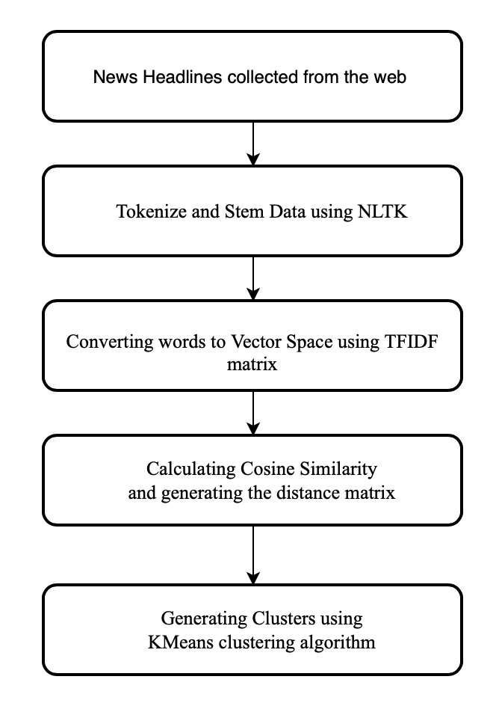
Fig. 1.Flowchart for classification of news headlines using K-Means Clustering.
Word Tokenization helps in splitting the sample sentences into words which are then transformed into their basic form and helps in removing the stop words. Cosine Similarity helps us in understanding the similarity of headlines [100]. Tfidfvectorizer helps in computing the word counts, idf and tf-idf values all at once. Finally, clusters are generated and headlines are assigned to different cluster based on the calculations and data passed.

3.2 Naïve Bayes

Naïve Bayes classifier is based on Bayes theorem. It uses probabilistic learning method for text classification [102]. They require a small amount of dataset to estimate necessary parameters [101]. However, its assumption that features are independent of each other in a given class makes this system suitable only for specific dataset that follow this rule for some extent [102].
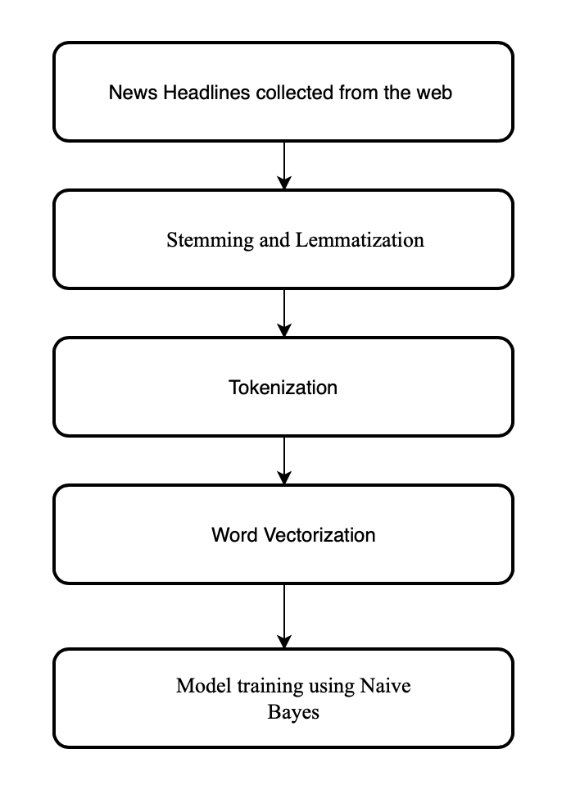
Fig. 2.Flowchart for classification of news headlines using K-Means Clustering.

Stemming is a process of converting the words to their base form. Lemmatization groups words with similar meaning in single group for analysis. These steps help in reducing the redundancy by removing multiple variant of the same word. Tokenization is the process of splitting sentences into words and vectorization is the process of counting the occurrence of the words in the dataset. The pre-processed dataset along with the metadata is passed to the classifier for training and prediction the of labels.

  - Random Forest Classifier

The labelled data is passed as an input to the random forest classifier where the feature extracting is done using N-Gram, after which the data used in trained of Random Forest Classifier. As shown in Fig. 2.
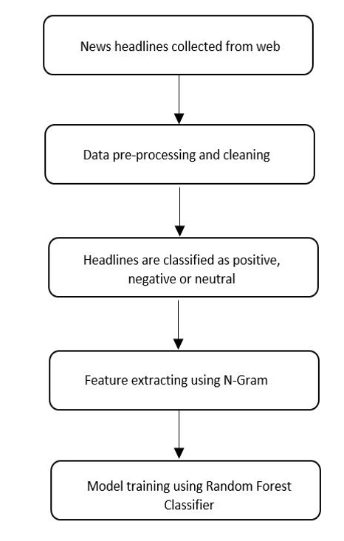
Fig. 3.Flowchart for classification of news headlines using Random Forest Classifier. (add reference)
The headlines are processed using N-Gram to make a bag of words. N-Gram in simple words means a sequence of N words from the sentence. Then using the random forest classifier model, headlines of the news are trained. A random forest is a meta estimator that fits a number of decision tree classifier on various sub-samples of the dataset and averaging to improve the predictive accuracy and control over-fitting [9]. By using this method the classifier can predict the labels of the news headlines.

3.4Support Vector Machine

Support Vector Machine (SVM) creates a hyperplane in N dimensions, which is used to classify data points. Since there is virtually no limit to the dimensions of the hyperplane SVM becomes very powerful in extracting features that may not be visible or are too complex to computed for other classification system.
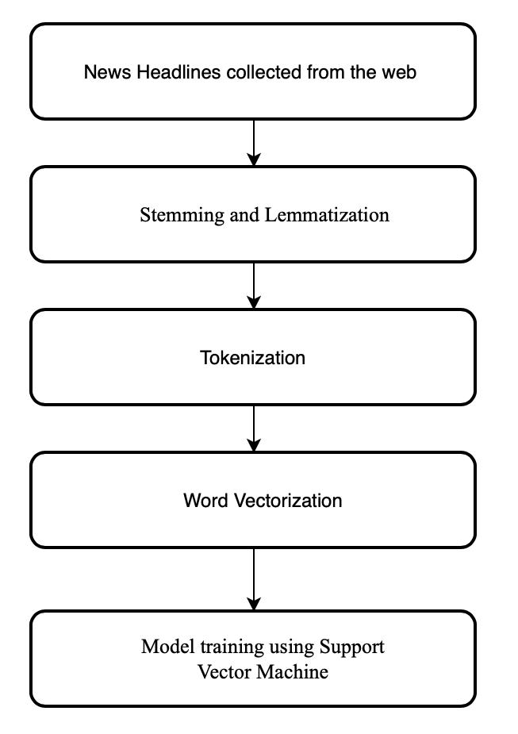
Fig. 4.Flowchart for classification of news headlines using Support Vector Machine.
In our experiment, the data preprocessing steps for SVM are same as Naïve Bayes system. SVM produces highly accurate results with very less computational power making it the preferred choice.

4 Results

The random forest classifier was trained on State Bank of India (SBIN) news headlines with the corresponding labels from 6th January, 2009 to 21st November, 2016. Fig. 5. shows the sample of training dataset.
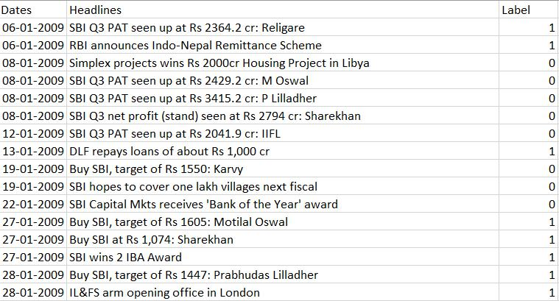

Fig. 5. Sample dataset to train the classifier.

The model classifies each word according to the respective label so when the head-lines are provided to this model, it can predict the labels for the headlines accurately. Comparing the predicted label values with the actual label values of the test dataset, we received an accuracy of 67.39%.

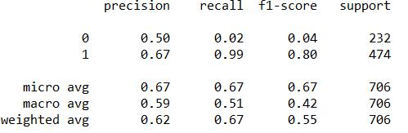

Fig. 6. Result summary.

The precision we got for label ‘0’ is 0.5 while the precision for label ‘1’ was 0.67. Fig. 6. Shows the analysis of the sentimental analysis on the news headlines of the SBIN.

5 Conclusion and Future Work

The proposed system is accurately following the pattern of the stock prices where the predicted values are in close vicinity to the actual market values. We have used the dataset of SBIN stock and achieved an accuracy of 97%, but the sudden fluctuations in the price of many stocks which are derived from abnormal events cannot be factored in the prediction system which is trained on past values of the respective stock prices. For such anomalies sentimental analysis of the event is required. We have implemented the system by analyzing the news which is available for any specific stock to reduce the deviation of the predicted prices from the actual prices. After adjusting the system and factoring in the sentimental analysis we have achieved an accuracy of 67.39%. RNN is robust in modelling complex relationships between parameters but it is not good enough to find its application in live trading system.

For future work adding more dimensionality to the dataset can further improve the accuracy of prediction. Global trends and events can be used to further improve the prediction of the stock’s direction for a longer timeline.

References

- Kar, A.: Stock Prediction using Artificial Neural Networks. In: Department of Computer Science and Engineering, IIT Kanpur.
- Barapatre, O., Tete, E., Sahu, C. L., Kumar, D., Kshatriya, H.: Stock Price Prediction using ArtificialNeural Network. In: International Journal of Advance Research, Ideas and Innovations in Technology vol. 4(2), pp. 916-922 (2018).
- Lawrence, R.: Using Neural Networks to Forecast Stock Market Prices. In: Department of Computer Science, University of Manitoba (1997).
- Akita, R., Yoshihara, A., Matsubara, T., Uehara, K.: Deep Learning for Stock PredictionUsing Numerical and Textual Information. In: IEEE/ACIS 15th International Conference on Computer and Information Science (ICIS) vol. 1, pp. 1-6 (2016).
- Fran, C.: Keras, http: //keras.io, 2015.
- Abadi, M., Agarwal, A., Barham, P., Brevdo, E., Chen, Z., Citro, C., Carrado, G. S., Da-vis, A., Dean, J., Devin, M., Ghemawat, S., Goodfellow, I., Harp, A., Irving, G., Isard, M., Jozefowicz, R., Jia, Y., Kaiser, L., Kudlur, M., Levenberg, J., Mané, D., Schuster, M., Monga, R., Moore, S., Murray, D., Olah, C., Shlens, J., Steiner, B., Sutskever, I., Talwar, K., Tucker, P., Vanhoucke, V., Vasudevan, V., Viégas, F., Vinyals, O., Warden, P., Wat-tenberg, M., Wicke, M., Yu, Y., Zheng, X.: TensorFlow: Large-scale machine learning on heterogeneous systems, http://tensorflow.org, 2015.
- Kingma, D., Ba, J.: Adam: A Method for Stochastic Optimization. In: 3rd International Conference for Learning Representations, San Diego (2015).
- Wallia, A. S.: Types of Optimization Algorithms used in Neural Networks and Ways to Optimize Gradient Descent, https://towardsdatascience.com
- Pedregosa, F., Varoquaux, G., Gramfort, A., Michel, V., Thirion, B., Grisel, O., Blondel, M., Prettenhofer, P., Weiss, R., Dubourg, V., Vanderplas, J., Passos, A., Cournapeau, D., Brucher, M., Perrot, M., Duchesnay, É.: Scikit-learn: Machine Learning in Python. Journal of Machine Learning Research vol. 12, pp. 2825-2830.
- Hunter, J. D.: Matplotlib: A 2D Graphics Environment. Computing in Science &Engi-neering vol. 9(3), pp. 90-95 (2007).

100.https://sites.temple.edu/tudsc/2017/03/30/measuring-similarity-between-texts-in-python/
101.H. Zhang (2004). The optimality of Naive Bayes. Proc. FLAIRS.

102. Kaviani, Pouria &Dhotre, Sunita. (2017). Short Survey on Naive Bayes Algorithm. International Journal of Advance Research in Computer Science and Management. 04.

103. Pedregosa, F. et al., 2011. Scikit-learn: Machine learning in Python. Journal of machine learning research, 12(Oct), pp.2825–2830.

104. Bird, Steven, Edward Loper and Ewan Klein (2009), Natural Language Processing with Python. O’Reilly Media Inc.

